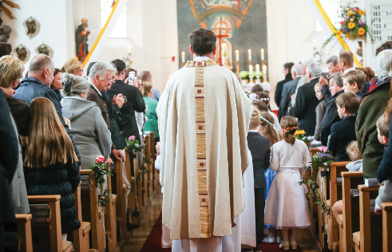

Parish Mission Planning
12 Step Planning Workbook

Parish Mission Planning
pastserv@gbdioc.org

Twelve Steps to a Successful Parish Mission Plan
As we enter into the prayerful, intentional, parish mission planning process, be comforted by Bishop Ricken’s exhortation and prayer:
“Remember friends, God is faithful, and will complete the good work He has begun in you, your families and within your parishes. You remain in my daily prayers as I continually entrust this and all of our diocesan efforts for the Kingdom to the care of our Blessed Mother, the Queen of Heaven and Our Lady of Good Help. As you go forward with your parish mission planning, I extend my apostolic blessing to your parish planning team.
-In the name of the Father and of the Son and of the Holy Spirit. Amen.”

Introduction
Thank you for your participation on your parish’s and school’s Parish Mission Planning (PMP) Team. Your active involvement in this planning process is extremely important towards the success of the plan; both in its development and in its implementation.
Those of us who are members of the Curia Parish Planning and Pastoral Services Mission Team realize that taking on a project like this can be somewhat overwhelming. This is especially true since this type of planning has never been done in this diocese, or any other diocese that we are aware of in our country. With this in mind, this manual has been developed in order to eliminate any sense of being overwhelmed by this project. This manual has been prepared in an easy to understand and straight forward manner. As a result of this, it is our hope that you will find it user friendly. As you will see, it is designed in a step by step process making it easy to define the scope of the work to be done at each planning session. It will also help you in scheduling out the work needed to complete the plan.
As you look through the manual and begin your planning process work, you will notice in the first five or six steps ways to retain information, ideas, and priorities for future planning purposes. Thus, this is a tool that the parish and school Parish Mission Planning Team can use year after year. This manual also provides an easy process of converting and distilling down a lot of statistical and anecdotal data into ultimately a manageable set of three (3) to five (5) goals supported by action steps. The necessary planning forms are included in this manual for ease of use.

*****************

The Essential Step
As all successful planning begins with the end in mind, it is recommended that as your team begins its work each time it meets to recite the Diocesan Vision and Mission statements. As any works in the Church are really the works of the Holy Spirit, it is essential that your team begins and ends with hospitality and prayer; the Diocese of Green Bay Discipleship Prayer by Bishop Ricken is good place to start.
Vision
We are missionary disciples striving to lead all people to the Kingdom of God.
Mission
As friends and followers of Jesus, we are dedicated to fostering households and communities of discipleship through the mission and ministry of the Catholic Church.
Discover Jesus - Follow Jesus - Worship Jesus - Share Jesus with Others
A Disciple’s Prayer
Oh, Good Shepherd, Jesus,
Help me to imitate You and reflect Your image to others,
Especially those whom I guide and serve.
Help me to think with your mind,
To see and gaze with your eyes,
To hear with your ears,
To speak with the words of your mouth.
Lord Jesus, use me to carry forth your mission,
As your servant and disciple,
Help me to carry out this work with your hands,
To be a voice for You in all that I say and do.
Merciful Shepherd, Jesus,
Help me to live in your Person,
To share generously in the carrying of your cross,
So that many others may be saved,
By coming to know and love You
Through my simple, faithful witness.
Glory be to the Father,
and to the Son and to the Holy Spirit,
As it was in the beginning,
is now and ever shall be, world without end.
Amen.

Summary of Twelve Steps of a Successful Parish Mission Plan
STEP 1 ASSESSMENT – HEALTH OF LEADERSHIP SURVEY
All ministry leaders, parish and school staff, board members, and council/committee members complete the Leadership Survey regarding their perception of the parish’s, the school's, and their own efforts in reference to evangelization, discipleship, leadership, and community impact. This survey will point out areas for improvement in these four areas. A list of the ten (10) major areas for improvement will be made by the planning team.
STEP 2 ASSESSMENT – OPERATIONAL AND MINISTRY CHECKLISTS
The appropriate personnel and school personnel fill out various checklists associated with parish and school operations. These checklists will point out areas for improvement in various areas of parish and school operations. A list of the ten (10) major areas for improvement will be made by the planning team.
STEP 3 ASSESSMENT – PARISH DATA SHEETS
The parish and school Parish Mission Planning (PMP) Team will review their data sheets regarding community and parish demographics, school and religious education enrollment as well as the youthfulness, faithfulness, contributions, and activity of the parish. The Parish Mission Planning (PMP) Team will list out their observations and up to five (5) recommendations as well as strategies for improvement in youth-faith and active membership in the parish.
STEP 4 ASSESSMENT – DISCIPLES ON THE WAY STRATEGIC PLAN FOR CATHOLIC SCHOOLS
The parish and school Parish Mission Planning (PMP) Team will review the Diocesan Strategic Plan for Schools and determine which goals in this plan will be a focus in the development of the parish and school Parish Mission Plan. No more than five (5) goals that stress collaboration and cooperation between the parish and school should be identified by the planning team as a major focus.
STEP 5 OBSERVATIONS/ANALYSIS
The Parish Mission Planning (PMP) Team compiles all of the lists developed in Steps 1 through 4 into one list. The list should be no longer than twenty (20) items.
STEP 6 ALIGNMENT TO CULTURAL VALUES/CLASSIFY ITEMS
The items listed in Step 5 are reduced to fifteen (15) items and appropriately assigned under the following categories by the planning team: Evangelization, Discipleship, Missionary Discipleship, and Community Impact.
STEP 7 SYNTHESIS
The planning team takes the list developed in Step 6 and reclassifies the items listed there into the categories of Enabling Evangelization, Empowering Collaborative Leadership, Expressing Abundant Sundays, Equipping Spiritual Maturity and Impacting the Communities in Which They Dwell. No more than ten (10) items are to be listed in this step. This information will be used by the planning team when they work on Step 8.
STEP 8 DETERMINE PRIORITIES
The planning team will sort through the list developed in Step 7 and begin categorizing the top three (3) to five (5) priorities for the Parish Mission Plan. Members of the Parish Mission Planning (PMP) Team vote as to what they think are the top three (3) to five (5) priorities for Year 1. Those three (3) to five (5) items with the most votes become the priorities that will be the focus of the Parish Mission Plan.
STEP 9 SET GOALS
The goals are concise statements of what the parish and/or school will do over the next one (1) to three (3) years to accomplish forming disciples, evangelizing, and impacting the greater community in which the parish and school are located. The goals and corresponding action steps are to be SMART: Specific, Measurable, Achievable, Results-Focused, and Time-Bound. The goals are put into the appropriate key categories of COMMUNITY IMPACT, ENGAGEMENT, AND GROWTH (Attendance, Enrollment, and Participation). It is recommended that no more than three (3) to five (5) goals be identified.
STEP 10 ACTION STEPS
The Parish Mission Planning (PMP) Team will develop a set of action steps for each of the goals identified using the template provided in the manual. On the template, list the goal at the top of the page; then under each goal list the supporting incremental action steps in chronological order by action step start date. Clearly state each step, the metric or evidence that will be used to show completion of the step, the person(s) responsible for carrying out the step, the human and financial resources necessary to complete each step, and the start and completion date for each step.
STEP 11 IMPLEMENTATION
Set the date to implement the plan according to the plan’s action steps. Make sure those responsible for the steps actually start work implementing the steps when they are scheduled to do so. Communicate the start of the action step(s) to the appropriate oversight body and/or constituents.
STEP 12 PERIODIC EVALUATION
Establish a plan evaluation process and schedule. Report the progress made toward the plan’s implementation to the appropriate oversight body and/or constituents according to the agreed upon schedule.

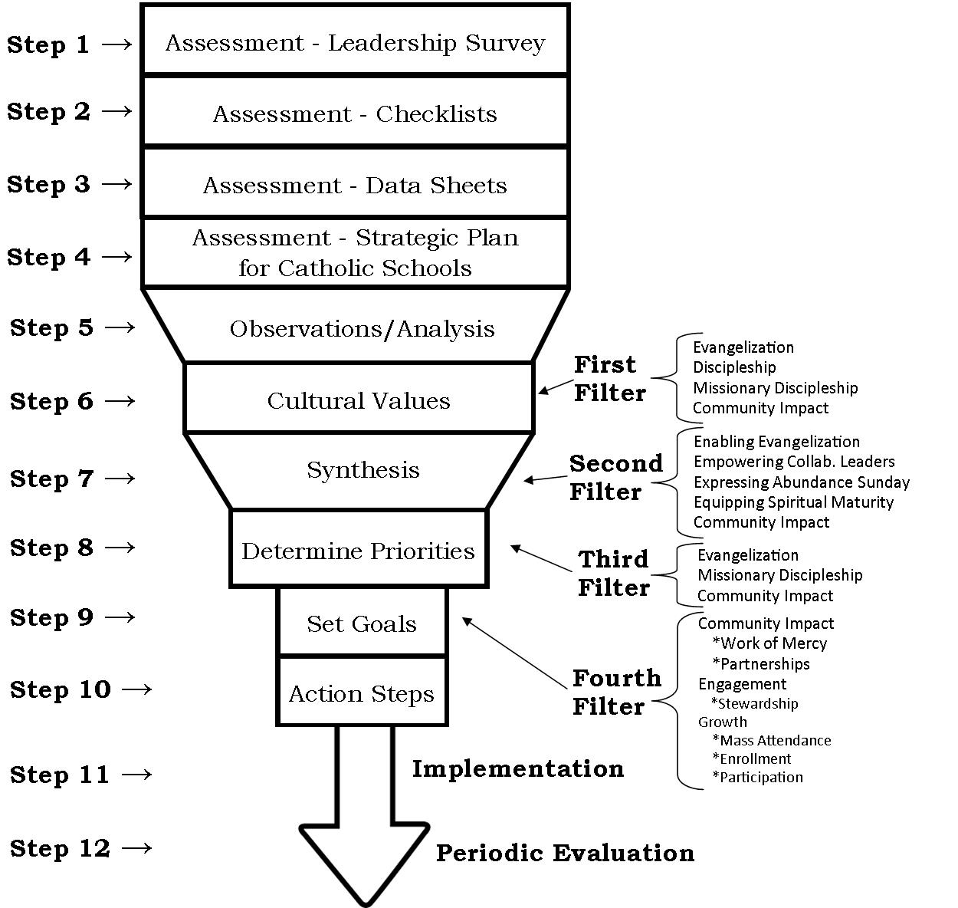
Twelve Steps to a Successful Parish Mission Plan – Chart

PMP: STEP 1 ASSESSMENT – HEALTH OF LEADERSHIP SURVEY
- The ministry leader, parish and school staff, board members, and council/committee members complete the electronic Health of Leadership Survey regarding their perception of the parish’s, the school’s, and their own efforts in reference to Evangelization, Discipleship, Leadership, and Community Impact.
- The Leadership Survey is completed online by all members of the PMP Team by the deadline set by the Parish Planning and Pastoral Services Department.
- The results of survey will be shared with the whole PMP Team and will point out areas for improvement in the four areas mentioned above.
- The PMP Team will review and discuss the results of the survey.
- The PMP Team will then list all of the areas that need improvement.
- Each member of the PMP Team will then vote on the top ten (10) areas that need improvement. They can use Post-It Notes, colored dots, or tally marks in casting their vote.
- Those ten (10) items with the most votes are then listed in order of importance by the PMP Team and retained for future processing and synthesizing (Step 5).
List
- ________________________________________________________________________
- ________________________________________________________________________
- ________________________________________________________________________
- ________________________________________________________________________
- ________________________________________________________________________
- ________________________________________________________________________
- ________________________________________________________________________
- ________________________________________________________________________
- ________________________________________________________________________
- ________________________________________________________________________

PMP: STEP 2 ASSESSMENT – OPERATIONAL & MINISTRY CHECKLISTS
- The appropriate personnel and school personnel fill out various checklists associated with parish and school operations.
- These checklists will point out areas for improvement in various areas of parish and school operations.
- The PMP Team will review and discuss the results of all the checklists.
- The PMP Team will then list all of the areas that need improvement.
- Each member of the PMP Team will then vote on the top ten (10) areas that need improvement. They can use Post-It Notes, colored dots, or tally marks in casting their vote.
- Those ten (10) items with the most votes are then listed out in order of importance by the PMP Team and retained for future processing and synthesizing (Step 5).
- A list of the ten (10) major areas for improvement will be made by the PMP Team and retained for future processing and synthesizing (Step 5).
List
- ________________________________________________________________________
- ________________________________________________________________________
- ________________________________________________________________________
- ________________________________________________________________________
- ________________________________________________________________________
- ________________________________________________________________________
- ________________________________________________________________________
- ________________________________________________________________________
- ________________________________________________________________________
- ________________________________________________________________________

PMP: STEP 3 ASSESSMENT – PARISH DATA & COMMUNITY ANALYSIS
- The parish and school PMP Team will review their parish data sheets regarding community and parish demographics, school and religious education enrollment as well as the youthfulness, faithfulness, contributions, and activity of the parish.
- The PMP Team will look at trends between 2008 and 2017 regarding registered households, Mass attendance, the reception of the sacraments of initiation and marriage, community and parish economic and demographic data, contributed units, community values, non-participation in religion, and the average contribution per contributor.
- The PMP Team will look for and identify connections between the various trends they observe utilizing the questions provided along with the parish data sheet.
- The PMP Team will list up to five (5) recommendations for improvement in youth-faith and active membership in the parish as well as community involvement based on their analysis of the parish data sheet.
- The PMP Team will then retain their list of no more five (5) items for future processing and synthesizing (Step 5).
List
- Youthfulness _______________________________________________________________________
- Faithfulness _______________________________________________________________________
- Contributions ________________________________________________________________________
- Active Membership ________________________________________________________________________
- Community Services & Organizations ________________________________________________________________________

PMP: STEP 4 ASSESSMENT – STRATEGIC CATHOLIC SCHOOL PLAN
• If the PMP Team has responsibility for mission planning for a Catholic school or system, the parish and school PMP Team will utilize electronic copies of the Strategic & Mission Plan for Catholic Schools for this step.
• The PMP team will review the Diocesan Strategic Plan for Catholic Schools and determine which goals in this plan will be integrated into the development of their common parish/school Parish Mission Plan (i.e. Goal 2 on page 4 of the Diocesan Strategic Plan for Schools).
• No more than five (5) goals that stress formation in discipleship, evangelization, collaboration and cooperation between the parish and school as well as community impact should be identified by the planning team as a major parish/school collaborative focus.
• The PMP Team will list no more than five (5) goals they have identified in this step and retain the list for future processing and synthesizing (Step 5).
List
1. _________________________________________________________________________
2. _________________________________________________________________________
3. _________________________________________________________________________
4. _________________________________________________________________________
5. _________________________________________________________________________

PMP: STEP 5 OBSERVATIONS / ANALYSIS
- The PMP Team compiles all of the lists developed in Steps 1 through 4 into one list. The list should be no longer than twenty (20) items.
List
1. _________________________________________________________________________
2. _________________________________________________________________________
3. _________________________________________________________________________
4. _________________________________________________________________________
5. _________________________________________________________________________
6. _________________________________________________________________________
7. _________________________________________________________________________
8. _________________________________________________________________________
9. _________________________________________________________________________
10. _________________________________________________________________________
11. _________________________________________________________________________
12. _________________________________________________________________________
13. _________________________________________________________________________
14. _________________________________________________________________________
15. _________________________________________________________________________
16. _________________________________________________________________________
17. _________________________________________________________________________
18. _________________________________________________________________________
19. _________________________________________________________________________
20. _________________________________________________________________________

PMP: STEP 6 ALIGNMENT TO CULTURAL VALUES & CLASSIFY ITEMS
- The PMP Team reviews the sheet outlining and defining the Diocesan cultural values.
- Utilizing the list of cultural values as a filter or framework, the PMP Team then takes
the list developed in Step 5 and reclassifies the items listed into the following categories designed to change the culture of the parish and school to enable a culture
of Evangelization, Discipleship, Missionary Discipleship, and Community Impact.
- There is to be a list of no more than fifteen (15) items listed. This information will be used by the planning team in Step 7. Once again, there needs to be at least one item listed under Community Impact.
Evangelization – bringing the Gospel into every human situation and seeking to lead individuals to the power of the Gospel.
List
1. _________________________________________________________________________
2. _________________________________________________________________________
3. _________________________________________________________________________
Discipleship – learning and living out the teachings of Jesus.
List
1. _________________________________________________________________________
2. _________________________________________________________________________
3. _________________________________________________________________________
Missionary Discipleship – bringing the message of Jesus to those who have left the practice of the faith or have never had any faith at all.
List
1. _________________________________________________________________________
2. _________________________________________________________________________
3. _________________________________________________________________________
Community Impact - providing personal and social solutions to the challenges present in the mission field in which the parish and school are located (needs to be at least one item listed).
List
1. _________________________________________________________________________
2. _________________________________________________________________________
3. _________________________________________________________________________

PMP: STEP 7 SYNTHESIS
- Each member of the PMP Team will now review the list of fifteen (15) items they developed in Step 6 and then vote on the top ten (10) areas that need improvement or a focus and assign those ten (10) items to the categories listed below.
- Note: It is alright if the PMP Team assigns more than two (2) items under any one of the ten (10) categories below or does not assign any items to one or more of the categories listed below. However, there needs to be at least one Community Impact item.

Ministry Area
Enabling Evangelization Education, Catechesis, Sac. Prep., RCIA
1. _________________________________*________________________________________
2. _________________________________*_______________________________________
3. _________________________________*_______________________________________
Empowering Collaborative Leadership Youth & Young Adult
1. __________________________________*_______________________________________
2. __________________________________*______________________________________
3. __________________________________*______________________________________
Expressing Abundant Sundays Liturgy & Worship
1. __________________________________*______________________________________
2. __________________________________*______________________________________
3. __________________________________*______________________________________
Equipping Spiritual Maturity Family Faith Formation
1. __________________________________*_______________________________________
2. __________________________________*______________________________________
3. __________________________________*______________________________________
Community Impact Social & Pastoral Care
1. __________________________________*______________________________________
2. __________________________________*______________________________________
3. __________________________________*_____________________________________

PMP: STEP 8 DETERMINE PRIORITIES
- The PMP Team at this point will sort through the lists developed in Step 7.
- Members of the PMP Team vote using Post-It Notes or colored dots as to what they think are the top three (3) to five (5) priorities for the plan. Those three (3) to five (5) items with the most votes become the priorities that will become the focus of the Parish Mission Plan.
- Once again, there needs to be at least one item listed under Community Impact.
- Note: The priorities identified in this fashion will become the goals used in developing the Parish Mission Plan.
List:
- ______________________________________________________________________

- _____________________________________________________________________

- _____________________________________________________________________

- _____________________________________________________________________

- _____________________________________________________________________

PMP: STEP 9 SET GOALS
- Taking the list of priorities listed in Step 8, the PMP Team will now transform the priorities into goal statements.
- The goals are concise statements of what the parish and/or school will do over the next one (1) to three (3) years to accomplish forming disciples, evangelizing, and impacting the greater community in which the parish and school are located.
- The goals are to be SMART: Specific, Measurable, Achievable, Results-Focused, and Time-Bound.
- The goals are listed under the appropriate categories of COMMUNITY IMPACT, ENGAGEMENT, AND GROWTH (Attendance, Enrollment, Participation).
- Note: It is alright if the PMP Team assigns more than one (1) item under any one of the five (5) goal categories. However, each plan must have at least one (1) Community Impact goal.
- It is highly recommended that no more than five (5) goals be identified.
COMMUNITY IMPACT (Community Works of Mercy, Partnerships with Agencies and Other Churches, Social Services, Participation in local events, etc.)
1. ___________________________________________________________________
2. ___________________________________________________________________
ENGAGEMENT (Stewardship, Capital Campaign)
1. ___________________________________________________________________
2. ___________________________________________________________________
GROWTH - Attendance (Mass attendance, Reception of the Sacraments)
1. ___________________________________________________________________
2. ___________________________________________________________________
GROWTH - Enrollment (Enrollment in Catholic School, Faith Formation, and Youth Ministry)
1. ___________________________________________________________________
2. ___________________________________________________________________
GROWTH - Participation (Sacramental Preparation, RCIA, Boards, Councils, Committees, etc.)
1. ___________________________________________________________________
2. ___________________________________________________________________

PMP: STEP 10 ACTION STEPS
- The action steps are those actions that will be taken in logical and chronological order to ensure the identified goal is achieved.
- With this step, the PMP Team develops a set of action steps for each of the goals identified in Step 9 using the templates provided at the back of this manual.
- These templates are designed for goals and corresponding action steps pertaining to Attendance, Enrollment, Engagement, Participation, and Community Impact.
- Under each goal list the supporting incremental action steps in chronological order by action step start date (see the example provided).
- Start by clearly and succinctly identify each step in easy to understand language.
- Next, you will indicate the metric or evidence that will be used to show completion of the step. Examples of metrics are meeting minutes, e-mail, posters, pictures, written testimonials, reports, etc.
- Next, it is extremely important to indicate the person(s) responsible for carrying out each step. This should be the person who will be held accountable for completion of the step.
- Then indicate separately the human and financial resources necessary to complete each step. Human resources could refer to a committee, task force, an outsourced entity, or an individual.
- Finally, indicate both the start and completion date for each step. Once again, please put the steps in chronological order according to the start date.

Goal and Steps Worksheet
GOAL:
STEP | METRIC | POINT PERSON | HUMAN RESOURCE | FINANCIAL RESOURCE | TIMELINE
1. |  |  |  |  | Start:
 |  |  |  |  | End:
2 |  |  |  |  | Start:
 |  |  |  |  | End:
3. |  |  |  |  | Start:
 |  |  |  |  | End:
4. |  |  |  |  | Start:
 |  |  |  |  | End:
5. |  |  |  |  | Start:
 |  |  |  |  | End:

PMP: STEP 11 IMPLEMENTATION
- The PMP Team, with the pastor’s or parish administrator’s approval, needs to set the date for implementing the plan according to the plan’s action steps.
- That action step that has the earliest start date within the plan is the date the plan’s implementation begins.
- It is imperative that those responsible for the steps actually start work implementing the steps when they are scheduled to do so.
- It is very important to communicate the start of the action step(s) to the appropriate oversight body and/or constituents. The pastor or parish administrator along with the PMP Team determine in collaborative fashion the proper oversight body and/or constituents.

PMP: STEP 12 PERIODIC EVALUATION
- The PMP Team will establish a plan evaluation process and schedule.
- The schedule for evaluating the plan’s progress will appear at the end of the Parish Mission Plan.
- They will also identify who will be involved in the evaluation process (i.e. Pastor, Pastoral Council, School Board, Parish Mission Planning Team, etc.).
- It is recommended that the progress on the plan be evaluated quarterly, if not monthly.
- It is also recommended that a chart or report regarding the plan’s progress be prepared and made available to the appropriate oversight body and/or constituents according to the agreed upon schedule.
Example:
The three (3) year Parish Mission Plan (July 1, 2018 – June 30, 2021), its implementation, and its results will be evaluated by (the appropriate person or group) according to the following schedule.

2018 | 2019 | 2020 | 2021
 | March 31 | March 31 | March 31
 | June 30 | June 30 | June 30
September 30 | September 30 | September 30
December 31 | December 31 | December 31

Depending on the results of the quarterly evaluation, the timeline for certain action steps may be altered (i.e. pushed forward or backwards). An assessment of the necessary human and financial resources needed to complete each step also will be determined at each quarterly evaluation.
A brief written, as well as oral, report will be given by (the person or organization) responsible for the implementation of the Parish Mission Plan meeting. A copy of this report will be given to the pastor, pastoral council and any other appropriate constituent groups.

The Diocesan Strategic Plan for Schools can be viewed and downloaded from: http://www.gbdioc.org/education-portal/catholic-schools; an excerpt of key recommendations is provided in this document “School and Parish Planning: Key Recommendations.”

