INFORMING THE PARISHIONERS

Outlined below is information regarding Parish Mission Planning. As a member of the Pilot Planning group, we invite you over the weekend to share information regarding the progress of parish planning team with your fellow parishioners. This would be appropriate to share during the time your parish shares announcements from the pulpit. This is meant to be transparent and keep parishioners informed. It may even cause them to action and find a way to get involved.

Thank you for your “YES” when called upon to serve. Please see the talking points below and incorporate them into your briefing for the parish. If you have questions, please direct them to your diocesan liaison.

How to share these talking points:
- Bulletin Announcement/Insert
- Parish Council Meetings
- Pulpit Announcements – Before or After Mass
- Website

Parish Mission Planning Overview

- Over the next several months, these parishes will be a part of the Parish Mission Planning project working with Parish Planning and Pastoral Services at the diocese.
- The mission of PMP is to inspire fundamental change in the mindset of how we approach parish and school planning – a paradigm shift from maintenance to mission.
- PMP is a realization, in the words of Pope Francis: “to devote the necessary effort to advancing along the path of a pastoral and missionary conversion which cannot leave things as they presently are. ‘Mere administration’ can no longer be enough…let us be ‘permanently in a state of mission (Evangelii Gaudium, #25).”
- PMP is not a program; it’s not “the next thing” after the Discipleship Seminars and Alpha program.
- PMP is a planning process designed to align and mobilize our church, parish, and ministry efforts to being missionary disciples leading all people to the Kingdom of God.
- PMP embodies the new diocesan vision and mission shared by Bishop Ricken in 2016, as well as his ongoing formation initiatives of Disciples on the Way.

- PMP begins with the end in mind, moving parish and school leaders toward a shared vision and common mission by:
  - Establishing one common parish planning process which incorporates traditional planning and cultural change toward evangelization and the process of discipleship.
  - Incorporating parish, Catholic Education, and capital campaign planning into one seamless process.
  - Orienting toward impacting communities in which parishes reside, which shifts planning from inward to outward-focused.
- PMP helps us realize in practical ways the hopes and dreams we have for ourselves, our parishes and schools, and our communities.
- Bishop Ricken has talked about pointing all of our efforts in the same direction, so that we’re stronger together – all pointing toward Jesus.
- PMP challenges us to realign our priorities and think differently about how we meet the needs of parishes and schools, to have a deeper impact in our communities.
- Parish Mission Planning (PMP) teams will be established at ALL parishes between now and 2020.

Suggestions on How to Share the Following Communication Points:
Talking points for parishes sharing information on their Parish Mission Planning Team.
- Over the past month, Pastor/Pastoral Leader, Team Facilitator, Tech Representative and School Representative have participated in a day-long seminar to help us build trust, learn about our parishes and schools and familiarize ourselves with the tools of this parish planning process. The members of our team are:
  - Name parish members participating on the team
    - Suggestion to go along with the naming the team, create a bulletin board with pictures of your team. This is also a place you can post regular updates for the parish.
• The PMP team is composed of people that reflect the cultures and demographics of our parish, school, and local community (age, vocation, profession, etc.).
- Parish Mission Planning provides a framework/model for one common parish planning process, for on-going parish planning and we are in the beginning stages now.
- Parish Mission Planning team members will work together to:
  - Place the needs of our parish/school and team above individual needs.
  - Be visionary about what our parishes and schools could look like.
  - Work collaboratively — sharing our true feelings, respecting those of others, and working through conflict constructively.
- Bishop Ricken asks us to discern how the Holy Spirit is moving in our community and challenges us to identify three to five goals that best serve our common mission of discipleship in our mission field (within our parish boundaries).

The point person for your team is asked to confirm with parish staff which weekend will work best for this briefing. Members of the planning team are asked to make themselves available following all the Masses on the chosen weekend to answer any parishioner questions.

As you move through the planning process, we suggest making these updates on a regular basis to keep parishioners informed. Your diocesan liaison and the Parish Planning and Pastoral Services team will continue to provide resources and tips for you to keep your parish current on your work and your Communications Liaison.

Thank you again for your leadership in the parish mission planning project.

Bulletin Insert Resources

In order to keep your parishioners informed about Parish Mission Planning, we have created some image headers that can be used with short articles which will be sent via email to all PMP pilot parishes. These are meant to fit into a column of your parish bulletin and can be adjusted to your specific needs.

Pick a header that fits the space you have, personalize the text with your parish’s specific information, and copy and paste the image and text into your bulletin editor.

Bulletin Insert Header Options
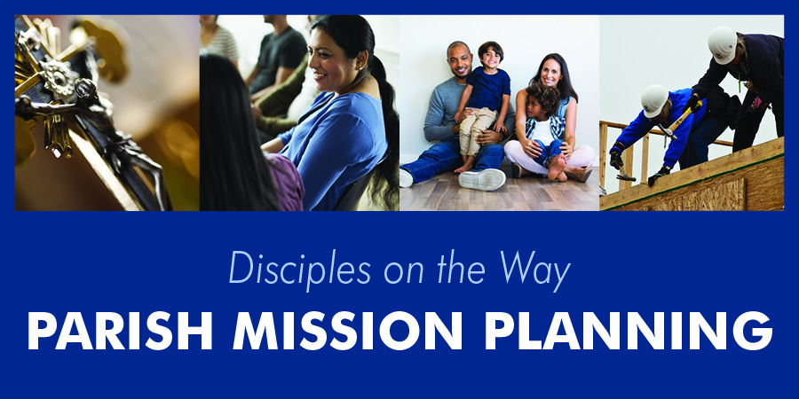
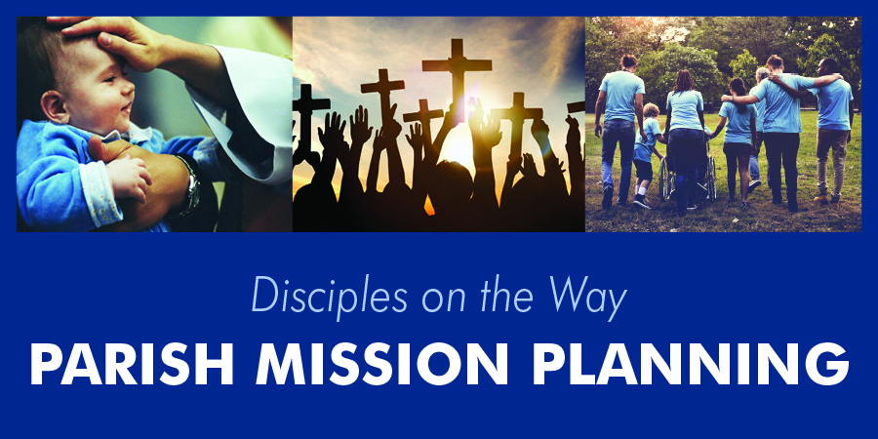

Parish Mission Planning
Friends and followers of Jesus,
It is with grateful hearts and a focus toward the future we share with you our parish’s participation in the pilot of an exciting new process called “Parish Mission Planning.” Parish Mission Planning you ask, what’s this? Parish Mission Planning aligns and mobilizes parish and school ministry planning efforts with the diocesan vision, mission, cultural values, and goals. Our parish leadership team is on fire for this process as we wrap our current vision/mission statement with Bishop Ricken’s vision/mission, using the key areas of Discover Jesus, Follow Jesus, Worship Jesus, and Share Jesus with Others as outlined in Disciples on the Way.

Parish Mission Planning focuses planning efforts on how our parish can engage in evangelization and discipleship collaboratively with Catholic schools and agencies residing in our community, our “parish mission field.” The plan will allow us to have a deeper impact in our community, parish, and schools; shifting from an inward to an outward-focused way of serving.

Our Parish Mission Planning team includes our pastor/pastoral leader, a team facilitator, parish and school leaders, lay ministers and parishioners representing various demographic groups, with assistance from our Diocesan Curia Offices. [You are encouraged to personalize this and insert names of your team here.] Our team will meet about six to nine times over the next few months, and as we progress we’ll keep you informed. Please stay tuned and keep us in your prayers as we move forward on mission.
Social Media Post Examples

Here are some examples of text you can use to post on your social media accounts like Facebook, Twitter, and Instagram.

Pair this text with pictures of your parishioners and/or school students and staff, your outreach efforts, and anything that showcases your community impact.

Example 1:
As a parish, we are called to bring the love of Jesus Christ to every soul in our mission field. Our mission field is the community directly surrounding our parish. It's not just about "us" any more. It's about everyone! Let's get out there and share the love of Jesus!

Example 2:
We're taking a hard look at how we impact our community with the love of Jesus. We want to reach everyone, whether they go to church every week or haven't stepped inside a church in years. It’s time for us to love and serve every soul, leading all people to the Kingdom of God!

